Web Dev Notes - DOM

# Section 24 – Intro to DOM

* **Document Object**
  + This represents the page itself. It is a JS object
  + 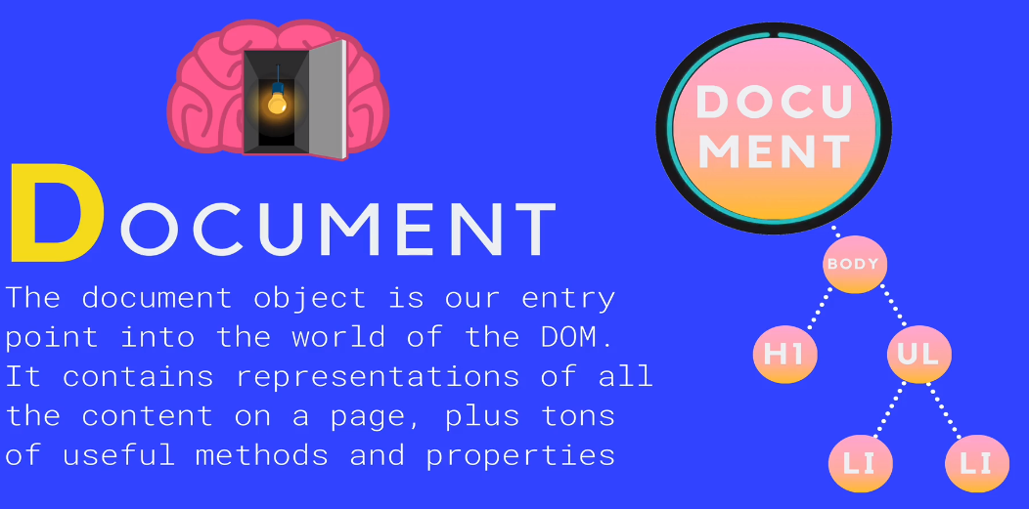
  + HTML and CSS components are converted into JS objects
* **SELECTING** methods are used to choose an element in your document
  + 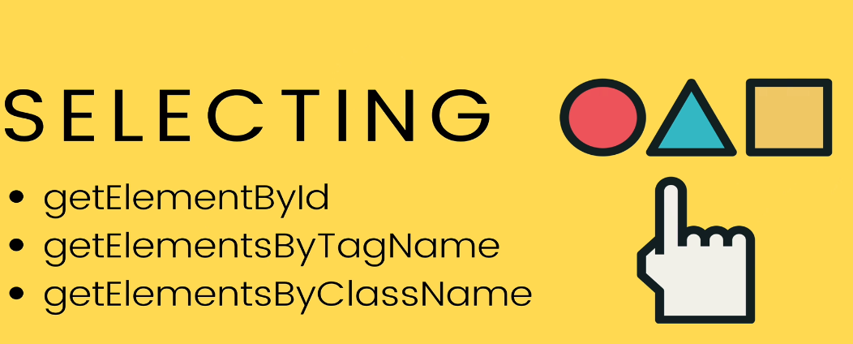
  + Example of **getElementById**
    - 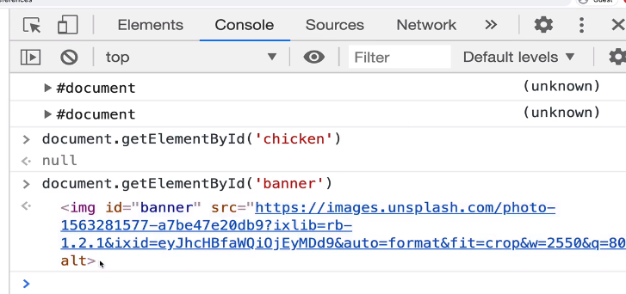
  + Example of **getElementByTagName**
    - Rebecca Donaldson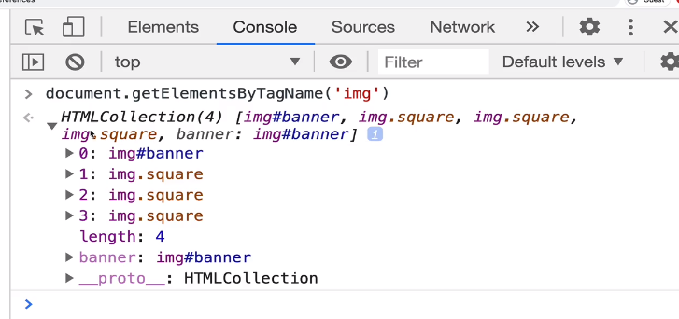
* **SELECTING Modernized:**
  + **QuerySelector()**
    - 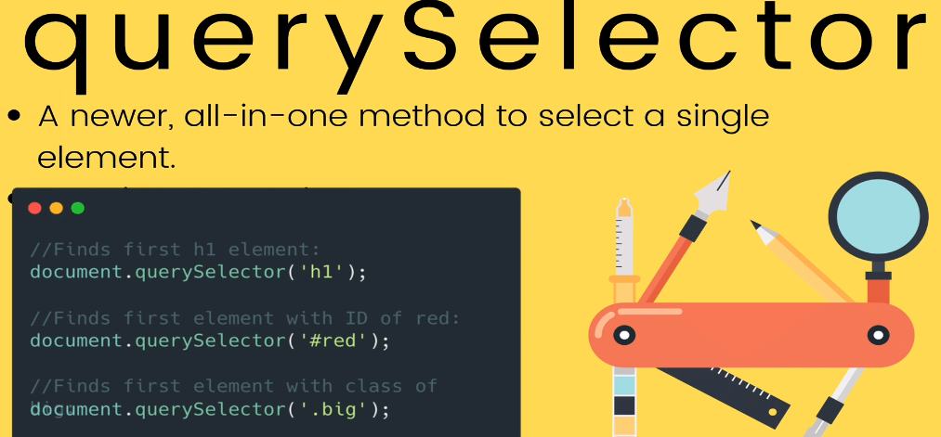
      * Just gives us the first matching element
  + **QuerySelectorAll()**
    - Returns a **collection** of matching elements
      * 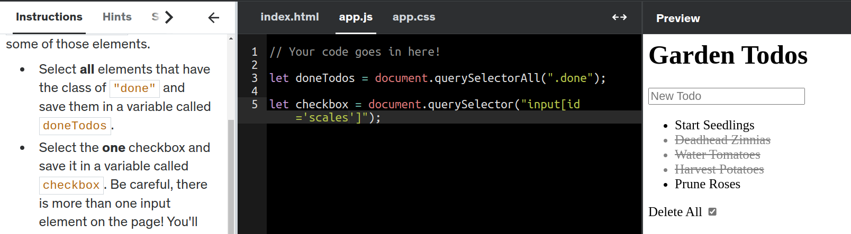
* **DOM MANIPULATION**
  + Methods and Properties of DOM
    - We're working hard to fix it, so please try again soon.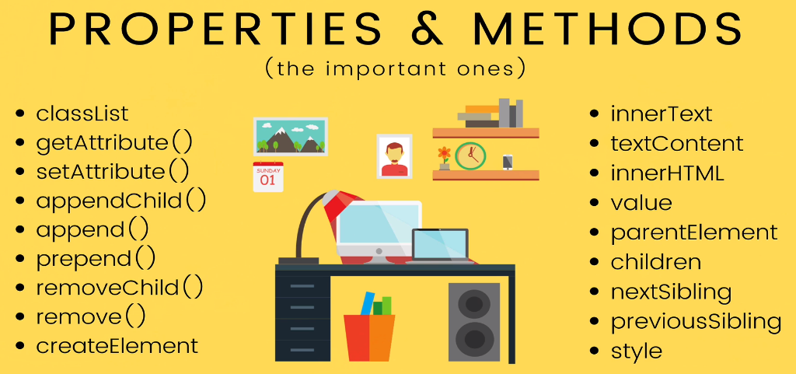
    - **Example of innerText, innerHTML and textContent**
      * 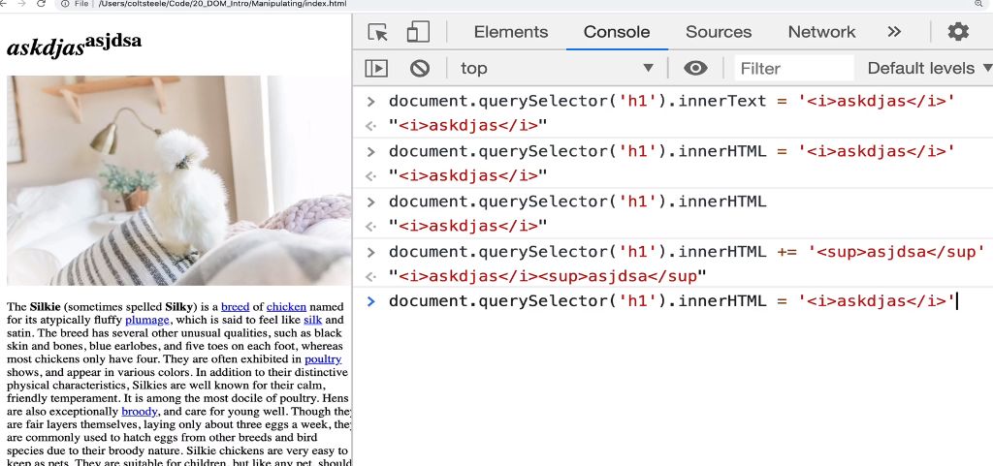
      * let updatedText = document.querySelector("h1 span").innerHTML = "<b>Disgusting<b>"
* **ATTRIBUTES**
  + Example of *src* attribute
    - 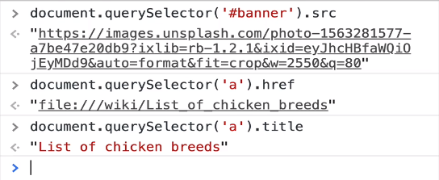
  + you can also use **getAttribute()** or **setAttribute()**
    - 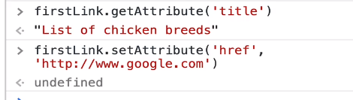
      * **Example**:
        + let source = document.querySelector('img');
        + source.setAttribute('src', 'https://devsprouthosting.com/images/chicken.jpg');
        + source.setAttribute('alt', 'chicken');
* **CHANGING STYLES**
  + <html tag>.**style**
    - **ex.** h1.style
    - Contains ALL props of CSS that a HTML tag can use
    - This style object DOESN’T contain the styles coming from a css style sheet (**ex**. app.css)
    - Instead, the style object is checking the ‘inline’ style settings in your HTML tag
      * **ex**. <h1 style=”color": blue”>blah</h1>
    - You can also use **window.getComputedStyle(h1)** to get all the css values per tag
    - 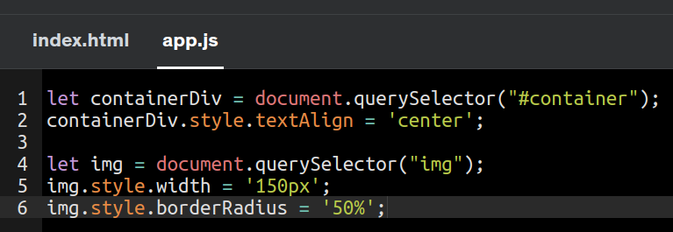
    - 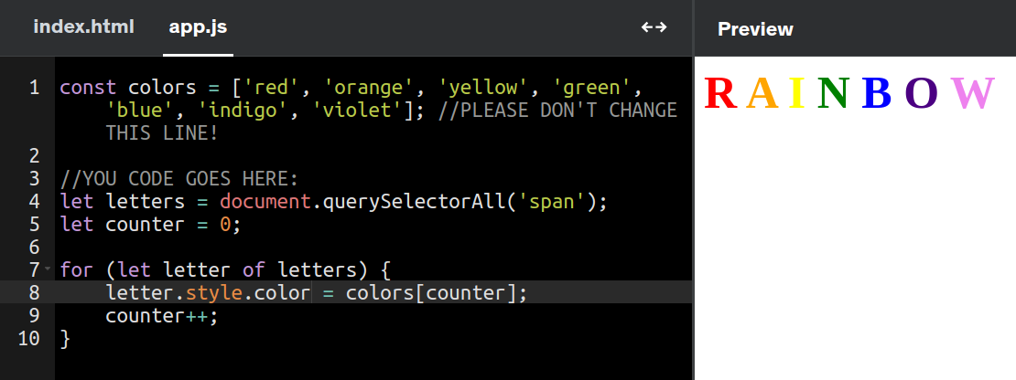
* **CLASSLIST**
  + **Option 1**: You can retrieve the class property of an element and then set it’s attribute/prop to a specific value
    - ex. 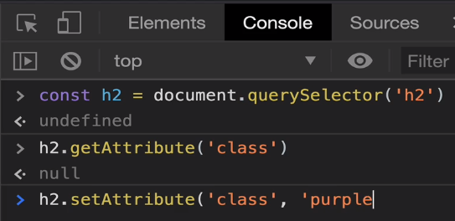
  + **BETTER option**: Use .classList to retrieve all classes under an element
    - 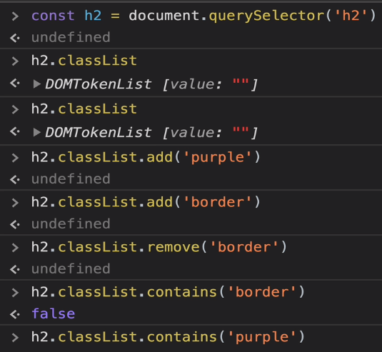
      * Using .**add** or .**remove** would change the class value in the tag
      * You can also use .**toggle** as it does those 2 operations
        + 
        + 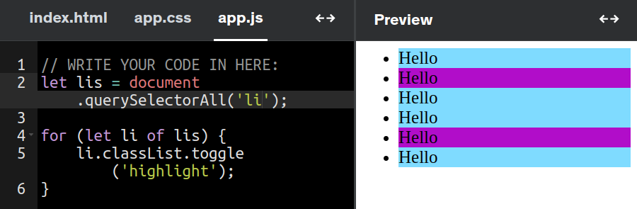
* **Traversing the DOM**
  + How to search through elements in the DOM from BOTTOM to TOP )
    - .parentElement
      * 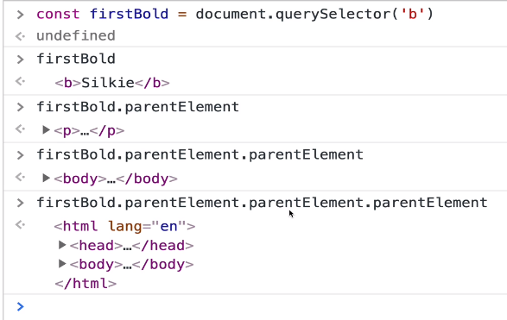
  + You can also search to see ALL the children underneath an element
    - * .children
      * 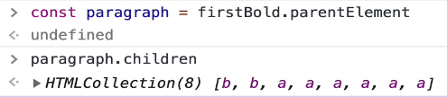
  + You can also search by adjacent sibling (.nextElementSibling)
    - 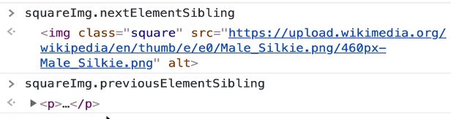
* **AppendChild**
  + **Steps**:
    - Create new elements and adding it to other elements
      * const newImg = document.createElement(‘<tag>’)
        + Ex. newImg.src = ‘<image location>’
    - AppendChild to parent tag
      * **Ex**. Append to body tag
        + 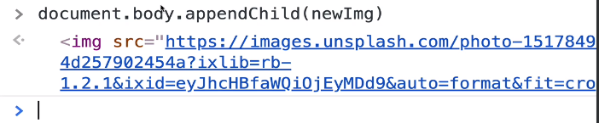
      * **Ex2**. Append a new h3 to body
        + 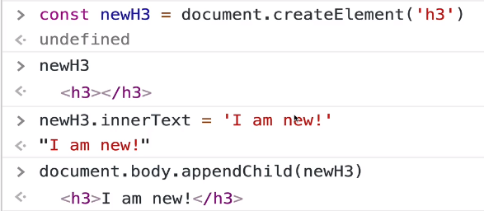
* **Append –** Similar, to appendChild but more flexible!
  + ParentNode.append() --> adds to end of node
    - You could append additional text into/inside a <p> tag
      * 
    - You could append multiple tags
  + .**prepend**() --> adds to beginning as first child of element
* .**insertAdjacentElement** --> Insert between elements
  + 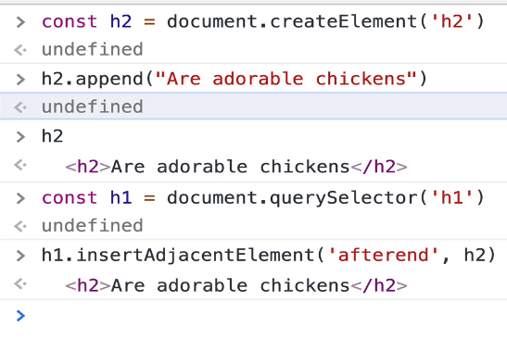 **=** 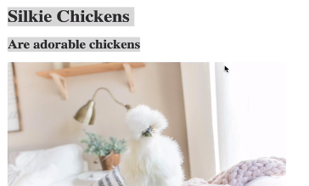
  + Inserted as next sibling, not as a child
    - 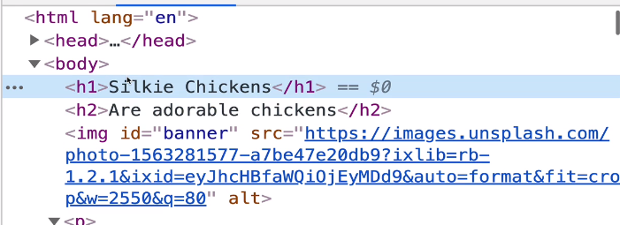
  + Exercise: Append 100 buttons to div as a child
    - 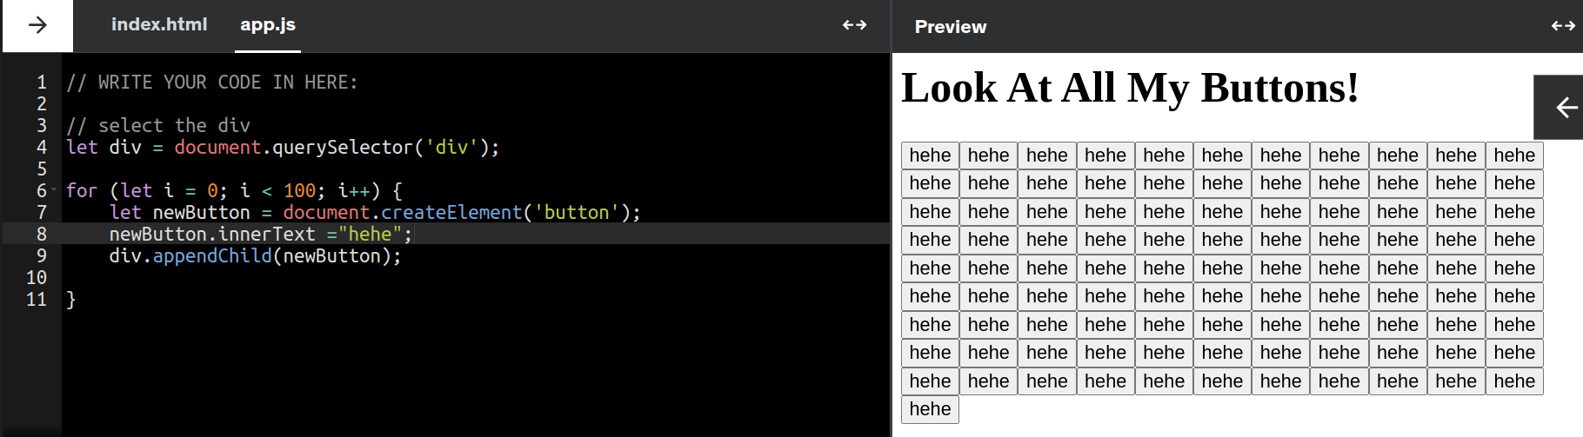
* **.removeChild**()
  + Removes the child from an element, not the element itself
    - 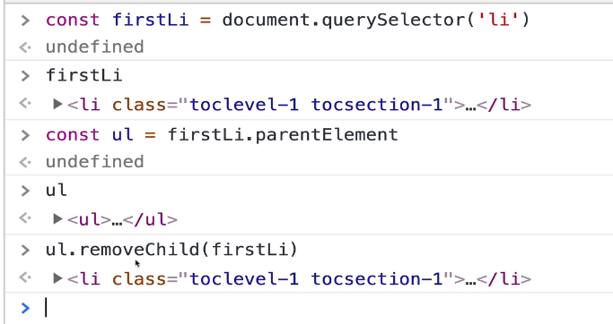
    - 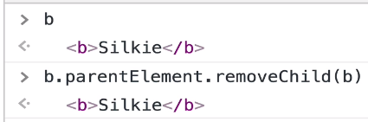
* .**Remove**() --> will remove the element it is called on
  + 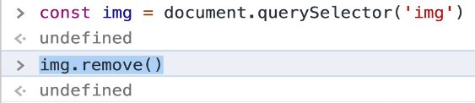

# Section 25 – DOM Events

* **Events = response to user input**
  + Some events:
    - 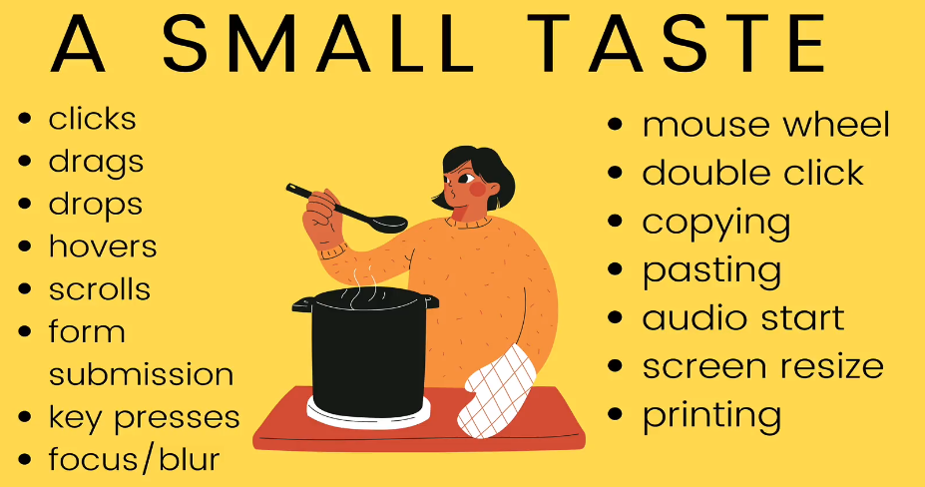
* **3 Types of Events to manage User Input**
  + 1) Inline Events (not recc)
    - use onClick:
      * 
  + 2) Onclick Property
    - Set this property as a function
      * 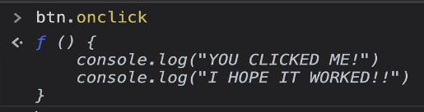
      * First in app.js, select the html element you want to alter the property for
        + Then add a function as a property of the element
        + 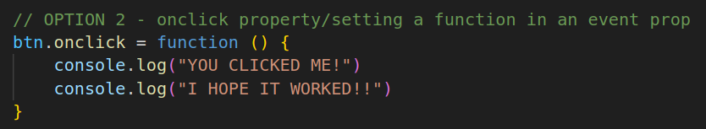
  + 3) addEventListener() (*best approach!*)
    - 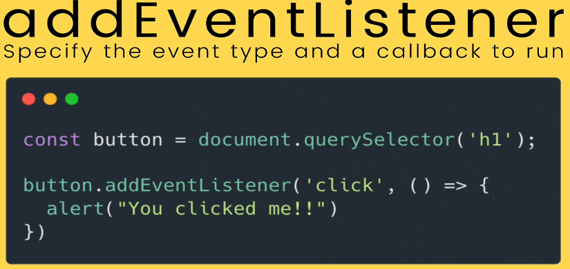
    - Takes 2 args: 1) event type; 2) callback function
    - This method works better because in option 2, you can only set 1 value for the property at a time. If you have 2 functions executing onClick, only 1 will run
    - addEventListener lets you run multiple functions
      * 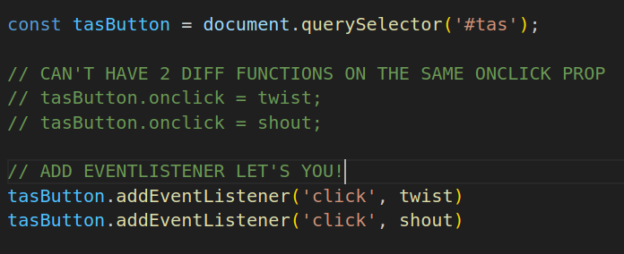
    - **Example**:
      * 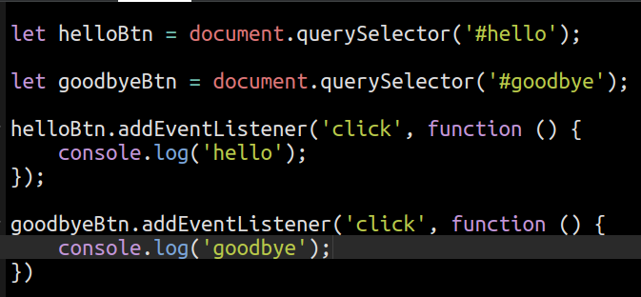
* **Events and THIS**
  + 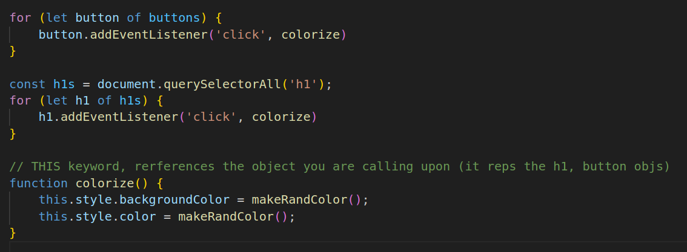
  + this --> references the object you are calling the function on
* **Event Object**
  + 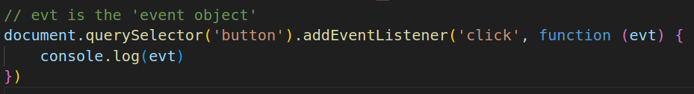
    - This object (evt or e)represents an event that’s occurred example: ‘mouseEvent’
    - IT is auto passed in by the event handler
      * 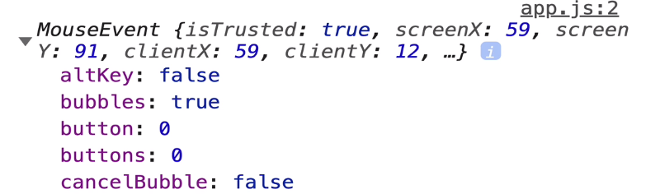
    - Consider these 2 properties in the KeyEvent:
      * console.log(e.key) --> the actual character that was pressed/actual result
      * console.log(e.code) --> the name of the key (location of key on keyboard)
      * **Output**:
        + 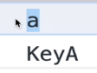
* **Form Events & PreventDefault()**
  + Form ‘actions’ send you to a new page
  + e.PreventDefault()
    - It prevents the default behaviour triggered by an event
    - 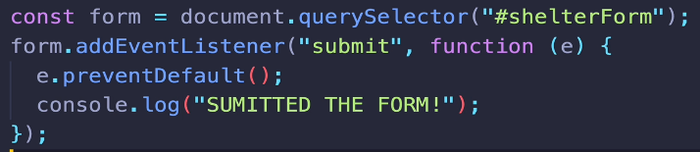
  + **Example**:
    - 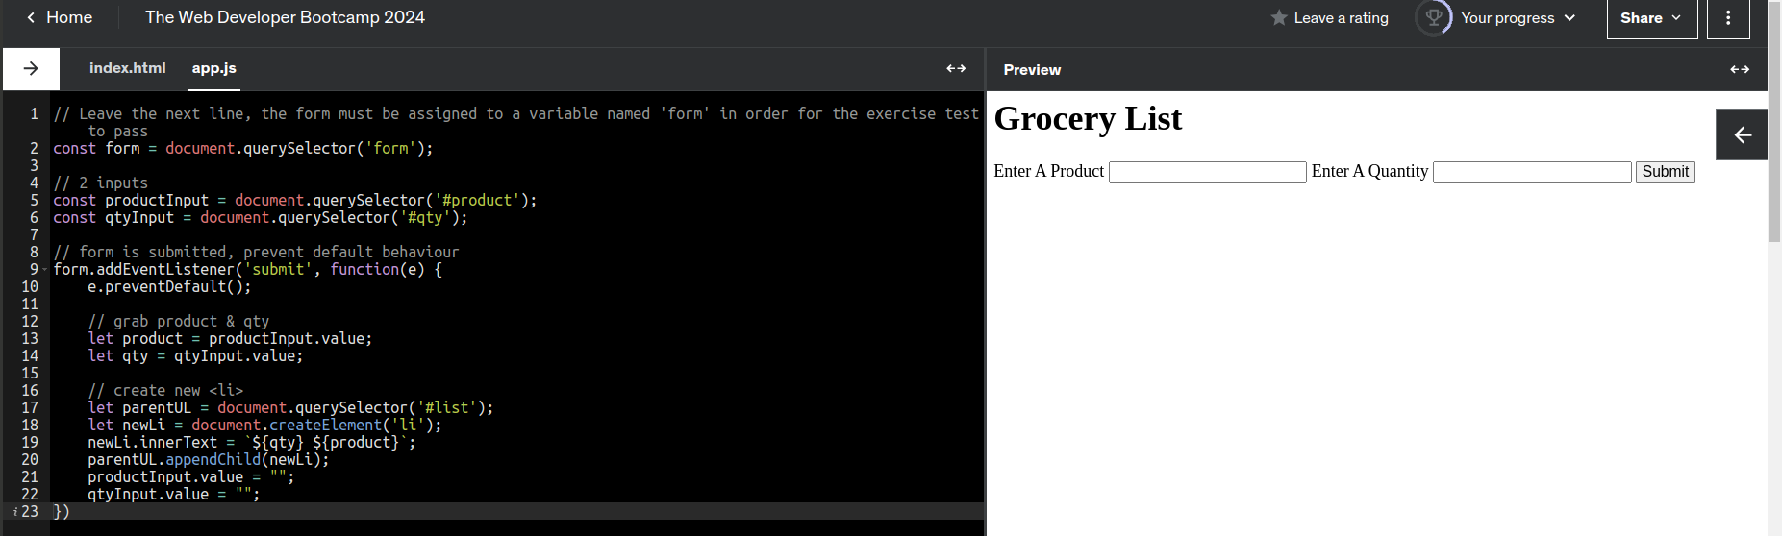
* **Change Events and Input Events**
  + 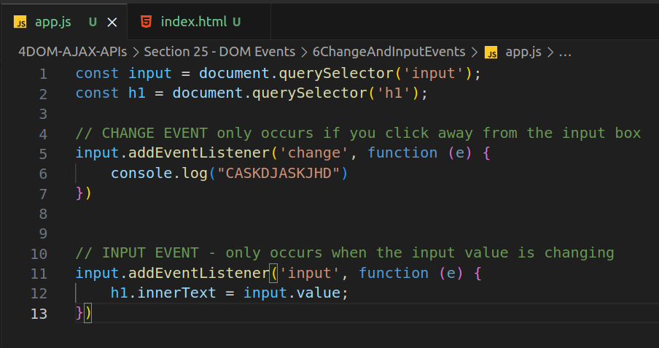
    - change event --> occurs when you enter a value and then click away from box
    - input event --> occurs when the input value changes
    - **Example**
      * 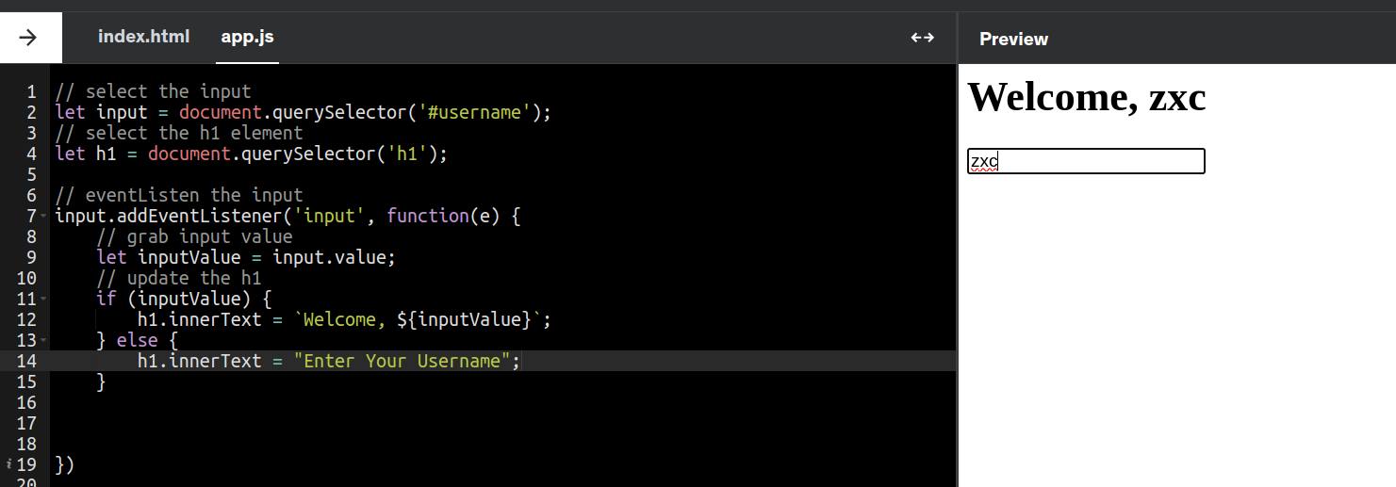
* **Event Bubbling**
  + Clicking on an element that is a child of other elements will cause the events to ‘bubble up’ aka trigger upwards
    - Clicking the <button>, triggers <p>, then <section>
      * 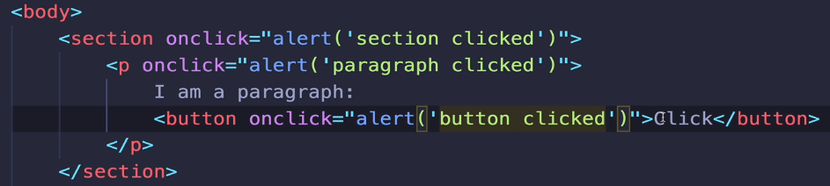
    - e.stopPropagation() --> stops the bubbling
      * 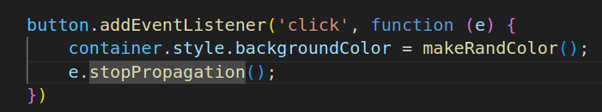
* Event Delegation
  + Newly created elements by .addEventListener don’t inherit the event listener (ex. New <li> won’t inherit the event listener that
  + Instead, use event delegation by adding event listener to the parent element. The child elements (newly created/already exist) will also get the same event listener
  + Example
    - 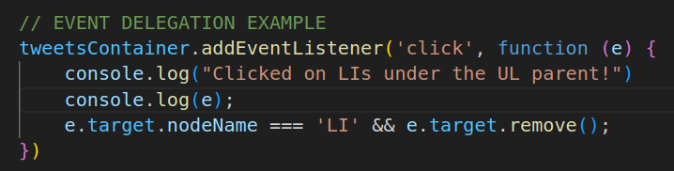
    - .target --> indicates the specific element clicked (ex. <li> under <ul> parent)